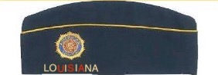
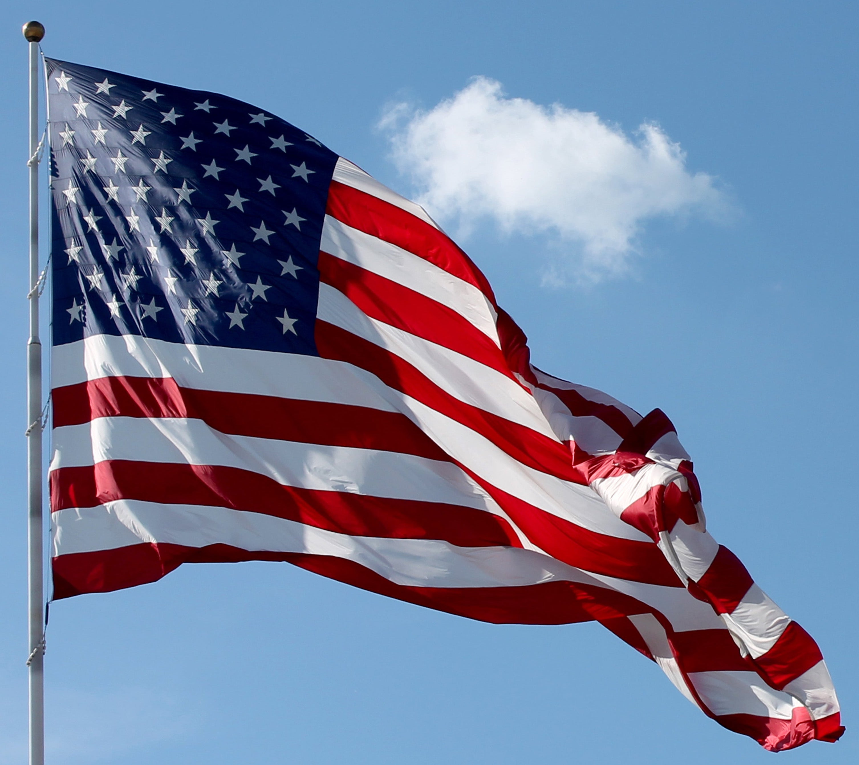



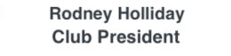
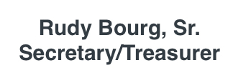
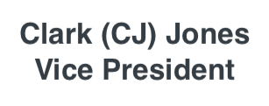

The Department of Louisiana American Legion
M.C "Mike" Gehr Blue Cap Award
The M.C. "Mike" Gehr Blue Cap Award is a very prestigious award which is funded by the Gehr family and is awarded annually on the District and Department levels. Every Post in our Department has a hard-working, dependable and volunteering member who has served his/her Post for at least 5 years and is deserving of being nominated.
- Use the Blue form only as a cover page. Please limit additional information to 1 (one) typewritten page and 2 (two) photographs.
- Any Post member, who is a former recipient of the award for the District, or the Post Commander, may nominate an individual from that Post for the award to the District Blue Cap Chair.
- On the Post level — former BLUE CAP recipients of the award should serve on the Post Selection Committee. The Post Selection Committee will have final approval of the Post Candidate. Only one nomination per Post is made to the District Blue Cap Chair by the assigned date. This application must be received by the District Blue Cap Chair, no later than 30 days prior to their District Spring conference.
- The District Blue Cap Chair should appoint a committee of 3 former recipients (not from the same Post of the nominee) throughout the District, to select the District Winner. At the Spring Conference, the District Blue Cap Chair or Commander must name and present Blue Cap District Winner with the prestigious Blue Cap Pin.
- The Club President will select a committee of 3 former recipients from 3 different districts chosen at the Mid–Winter Conference, who will be mailed the District Winners. After careful review of all District Nominations, in private, they will list on the secret ballot provided; their 1st, 2nd, and 3rd choices. This Secret Ballot, should be mailed to the Blue Cap President, Vice President, and Secretary/Treasurer who do not vote. They tally the votes and announce the winner at the Department Convention.
- The respective District Chair or Commander will notify the Club President and make every attempt at assuring the presence of the District Winner at their Spring Conference, to be honored and awarded the prestigious Blue Cap Pin and encourage to attend the State Convention as a State Nominee.
- The Department Winner, at Convention will be presented the Department Blue Cap Plaque.
- Any Blue Cap Club Member dismissed or expelled from the American Legion will be removed as a Member of the M.C. “MIKE” GEHR CLUB

BLUE CAP DISTRICT CHAIRS

1st Sidney Parfait | 504-416-4098 (cell) | 2nd William Ello | 504-858-8822 (cell)
sapcpa01@gmail.com |  | wjello@gmail.com
3rd Rudolph “Rudy” Bourg, Sr. | 337-298-3201 (cell) | 4th Linda Resendez | 318-458-0573 (cell)
rabourgsr@gmail.com |  | resendezdl@aol.com
5th Tina Cielatka | 318-791-4181 (cell) | 6th Mike Peats | 985-502-8802 (cell)
Tmctalbs2023@yahoo.com |  | m484048@bellsouth.net
7th Sam Doucet | 337-368-7721 (cell) | 8th Herman Smith | 337-718-1351 (cell)
Bars4@charter.net |  | hermansmith022753@yahoo.com

Application for M.C. "Mike" Gehr Blue Cap Award

To: District Blue Cap Chair (Listed on reverse side) __________ ,
We of Post #________________________________________________________ have selected

(first name) (middle initial) (last name)
(mailing address) (city) (zip code)

(telephone number) (cell number) (email address)
As the Outstanding Legionnaire of Post ____ and submit his/her qualifications for the Blue Cap award eligibility:
- He/she has been a member of the American Legion Dept of Louisiana for a minimum period of “5” years and has never been elected or appointed to a District Position of Area Commander or higher within The AL.
- He/she has been elected to the following Post offices:
- He/she has served as Chairman of Post Committees which represent the betterment of The A.L. and the welfare of veterans and has helped to secure new and/or renewal memberships.
- He/she has been an active worker in the following American Legion Post Programs:
- He/she has been active in civic and church affairs in their community in the name of the American Legion as follows:
- He/She must NOT HAVE BEEN COMPENSATED for applicable services in their Posts and/or The American Legion.
- Post Commanders or former recipients can mail their nominee form to their District Blue Cap Chair no later than 30 DAYS PRIOR to their Spring District Conference.

Blue Cap Club Officers:

President: Rodney S. Holliday
504 Davella / DeRidder, LA 70634
337-396-1112 cell / holliday19@bellsouth.net

Vice President: Clark “CJ” Jones
167 Ernest Williams Road / Leesville, LA 71446
337-397-2968 cell / jokerjr1349@gmail.com

Secretary/Treasurer: Rudolph “Rudy” Bourg, Sr.
103 Copal Drive / Youngsville, LA 70592
337-298-3201 / rabourgsr@gmail.com

District Blue Cap Chair: Mail District Winner To: RODNEY S. HOLLIDAY / PRESIDENT BLUE CAP CLUB
504 DAVELLA DRIVE / DERIDDER, LA 70634

