BACK BY POPULAR DEMAND

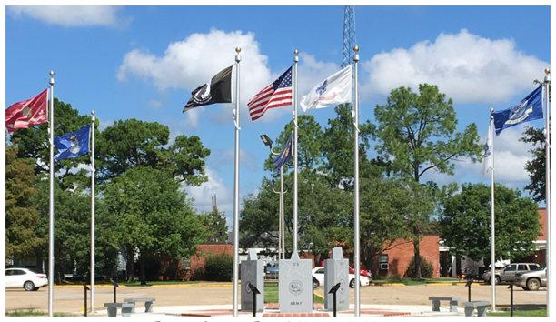

The Pointe Coupee Parish
Veteran's Monument Committee
Will Begin Selling More Bricks

Starting: Monday, January 23, 2017

Deadline: Friday, June 16, 2017
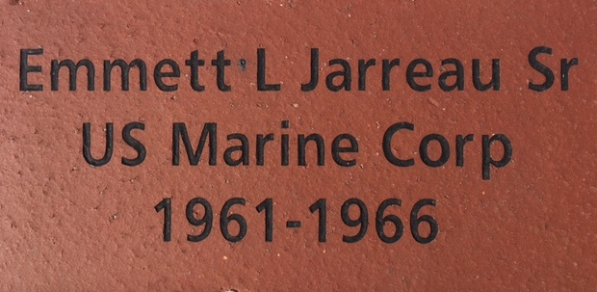

Printable Brick Forms Click Here:

Or go to:
http://files.constantcontact.com/798871bc001/7b69a31e-88ec-48a5-a961-597a2ebbc063.pdf

Or You May Go Visit:
www.lalegion.org
Click on District/Post News
Click on Post 248 from Drop Down Menu

Pick Up Or Drop Off:
Guaranty Bank Drive Through Window
175 New Roads Street
New Roads, LA 70760

Follow Directions on The Form To Mail

For More Information Contact:
Anthony Daisy; Phone: (225)638-9009, cell: (225) 718-1575, or E-mail: tdaisy50@bellsouth.net
George Miller; Phone: (225) 287-4068 or Email: chacha46@bellsouth.net
Jamie Lecoq; Phone: (225) 937-1686 or Email: bigmac723@gmail.com
Benn Farrar; Phone: (504) 220-7918 or Email: BenFarrar@att.net
Camille LeJeune; Phone: (225) 638-3328; cell (225) 718-0896, Email: lamembership@yahoo.com

